**PROJECT REPORT**

*On*

**ADOPTION OF HYDROPONICS AS A SUSTAINABLE ORGANIC FARMING PRACTICE**

**Submitted by:**

**(Group No : 21)**

**Divyansh Kumar Singh (24AG65R08)**

**Pranjali Diliprao Patil (24AG65R05)**

**Chaithra SN (24AG65R06)**

**Vaibhav Shivaji Bhawar (24AG65R04)**

**Nagendra Singh Parihar (24AG65R07)**

**Aditya Mandloi (24AG65R01)**



**AQUACULTURAL ENGINEERING**

**AGRICULTURAL & FOOD ENGINEERING DEPARTMENT**

**INDIAN INSTITUTE OF TECHNOLOGY KHARAGPUR, WEST BENGAL, INDIA- 721302**

**CONTENT**

|  |  |
| --- | --- |
| **Topics** | **Page no.** |
| Introduction | 3 |
| Literature Review | 4-5 |
| Methodology | 6-10 |
| Findings | 10-11 |
| Analysis | 12 |
| Importing Data | 13 |
| Indicators | 14-15 |
| Correlation | 16-17 |
| Measurement Model | 18 |
| Some screenshots of Variability in Responses | 19-20 |
| Conclusion | 21-22 |
| References | 23-24 |

**INTRODUCTION**

The global agricultural landscape is undergoing significant transformation due to the pressing challenges of climate change, limited land, and water scarcity. These issues are further exacerbated by the growing global population, which demands increased production of high-quality, nutritious food. Traditional soil-based farming methods are often unsustainable in arid regions and areas with limited fertile land, leading to the exploration of alternative agricultural systems that can ensure food security without compromising environmental sustainability. One such promising alternative is hydroponics, a soilless cultivation method that allows plants to grow in a controlled environment using nutrient-rich water solutions. Hydroponic systems are highly efficient in their use of water and nutrients, making them particularly suitable for regions facing water scarcity and poor soil quality. These systems can be implemented on both large and small scales, offering flexibility and adaptability to various environmental conditions.

This project aims to explore the adoption of hydroponics as a sustainable organic farming practice. The primary objectives are to evaluate the efficacy of organic-based nutrient solutions in hydroponic systems, compare the performance and nutritional quality of crops grown with organic versus synthetic nutrient solutions, and identify the limitations and potential improvements in organic hydroponic systems.

**LITERATURE REVIEW**

* **Challenges in Conventional Agriculture**

Conventional agriculture faces significant challenges, including climate change, limited arable land, and water scarcity (Ponomi et al., 2023). The repurposing of agricultural land for residential and industrial developments further exacerbates these issues, particularly in arid regions where agricultural production is already constrained (Kurowska et al., 2020). These challenges necessitate the exploration of alternative agricultural systems that can ensure food security without compromising environmental sustainability.

* **Environmental and Health Concerns with Synthetic Fertilizers**

Despite the efficiency of hydroponic systems, they typically rely on synthetic chemical fertilizers, which pose environmental and health risks. Excessive use of synthetic fertilizers can lead to soil degradation, water pollution, and potential health risks for consumers (Bergstrand, 2022). The increasing environmental awareness and consumer demand for organic products have led to a growing interest in developing organic hydroponic systems (Di Gioia & Rosskopf, 2021).

* **Hydroponics as an Alternative Farming Method**

Hydroponics, a soilless cultivation method, has emerged as a promising solution to these challenges. Hydroponic systems use nutrient-rich water solutions to grow plants, allowing for efficient use of water and nutrients (Putra & Yuliando, 2015). These systems can be implemented in various environments, including urban areas and regions with poor soil quality, making them highly adaptable and scalable (Singh et al., 2020). Hydroponics also offers the potential for year-round production, reducing the dependency on seasonal changes and enhancing food availability (Dubey & Naik, 2020).

* **Organic Hydroponics: Opportunities and Challenges**

Organic hydroponics, or bioponics, involves the use of organic-based nutrient solutions derived from natural sources such as fish farm waste, plant residues, and humic materials (Wang et al., 2019). These systems aim to combine the efficiency of hydroponics with the environmental and health benefits of organic farming. However, the transition to organic hydroponics presents several challenges. Organic fertilizers require mineralization by microorganisms to release nutrients in forms that plants can absorb, which can be slower and less predictable than the immediate availability of nutrients from synthetic fertilizers (Bergstrand, 2022). This can lead to variations in crop yield and quality (Ahmed et al., 2021).

**METHODOLOGY**

**Research Design:**

This project adopts a quantitative research design to investigate the adoption of hydroponics as a sustainable organic farming practice. The study will use a survey-based approach to collect data from fulltime farmers, part time farmer, students, agricultural experts, and stakeholders involved in hydroponic farming. The data will be analyzed using Excel for descriptive statistics and SmartPLS for structural equation modelling (SEM) to understand the factors influencing the adoption of hydroponics

**Target Population:**

The target population includes farmers, agricultural experts, hydroponic farm owners, and stakeholders in the agricultural sector who are familiar with or have adopted hydroponic farming practices.

**Sampling Method:**

A **stratified random sampling** method will be used to ensure representation from different regions and farming backgrounds. The sample size will be determined based on the population size and the desired confidence level (e.g., 95% confidence level with a 5% margin of error).

**Questionnaire Design:**

The questionnaire will be designed to collect data on the following key areas:

* **Demographic Information**: Age, gender, education level, farming experience, and region.
* **Awareness and Knowledge**: Awareness of hydroponics, knowledge of organic farming practices, and understanding of sustainable agriculture.
* **Adoption Factors**: Factors influencing the adoption of hydroponics, such as cost, perceived benefits, environmental concerns, and government support.
* **Challenges**: Challenges faced in adopting hydroponics, including technical, financial, and regulatory barriers.
* **Perceived Benefits**: Perceived benefits of hydroponics, such as water efficiency, higher yield, and reduced environmental impact.
* **Behavioral Intentions**: Willingness to adopt hydroponics and recommendations for improving adoption rates.

The questionnaire will use a **5-point scale** (1 = Strongly Disagree, 5 = Strongly Agree) to measure respondents' attitudes and perceptions.

**Questionnaire link-** [**https://forms.gle/Q1ivynTLej6jEyS96**](https://forms.gle/Q1ivynTLej6jEyS96)

**Data Collection:**

* **Survey Distribution**: The questionnaire will be distributed online using platforms like Google Forms or SurveyMonkey to reach a wide audience. It will also be distributed physically in agricultural communities and hydroponic farming centers.
* **Pilot Testing**: A pilot test will be conducted with 20-30 respondents to ensure the clarity and reliability of the questionnaire. Feedback from the pilot test will be used to refine the questionnaire.
* **Data Collection Period**: Data will be collected over a period of 4-6 weeks.

**Data Analysis:**

The collected data will be analyzed using Excel and SmartPLS as follows:

**Step 1: Data Cleaning and Preparation**

* Use Excel to clean the data by removing incomplete or inconsistent responses.
* Organize the data into categories for analysis (e.g., demographic data, adoption factors, challenges, etc.).

**Step 2: Descriptive Statistics**

* Use Excel to calculate descriptive statistics such as mean, median, mode, standard deviation, and frequency distributions.
* Create charts and graphs (e.g., bar charts, pie charts) to visualize the data.

**Step 3: Reliability and Validity Testing**

* Use **Cronbach’s Alpha** in Excel or SmartPLS to test the reliability of the questionnaire items. A Cronbach’s Alpha value of 0.7 or higher indicates good reliability.
* Conduct **Exploratory Factor Analysis (EFA)** in SmartPLS to assess the validity of the constructs.

**Step 4: Structural Equation Modeling (SEM) in SmartPLS**

* Use SmartPLS to perform **Partial Least Squares Structural Equation Modeling (PLS-SEM)** to analyze the relationships between variables.
* Key steps in SmartPLS:
* **Model Development**: Develop a conceptual model with constructs such as awareness, adoption factors, challenges, and behavioral intentions.
* **Measurement Model**: Assess the reliability and validity of the constructs using **Composite Reliability (CR)** and **Average Variance Extracted (AVE)**.
* **Structural Model**: Test the hypothesized relationships between constructs (e.g., the impact of awareness on adoption).
* **Path Analysis**: Analyze the strength and significance of the relationships between variables.
* **Goodness-of-Fit**: Evaluate the model fit using indices such as **R²**, **Adjusted R²**, and **Q²**.

**Step 5: Hypothesis Testing**

* Test the hypotheses using the **t-values** and **p-values** generated by SmartPLS. For example:
  + H1: Awareness of hydroponics positively influences adoption.
  + H2: Perceived benefits positively influence adoption.
  + H3: Challenges negatively influence adoption.

**Step 6: Interpretation of Results**

* Interpret the results of the SEM analysis to understand the key factors influencing the adoption of hydroponics.
* Provide recommendations based on the findings.

**Ethical Considerations:**

* Obtain informed consent from all participants before data collection.
* Ensure the confidentiality and anonymity of respondents.
* Use the data solely for research purposes and avoid any misuse.

**Expected Outcomes:**

* Identification of key factors influencing the adoption of hydroponics as a sustainable organic farming practice.
* Insights into the challenges and barriers faced by farmers in adopting hydroponics.
* Recommendations for policymakers, agricultural experts, and stakeholders to promote the adoption of hydroponics.

**FINDINGS**

Based on the methodology outlined, the findings of the project could be categorized into several key areas. These findings would be derived from the analysis of survey data using Excel and SmartPLS, and they would provide insights into the factors influencing the adoption of hydroponics as a sustainable organic farming practice. Below are the potential findings:

**Awareness and Knowledge of Hydroponics:**

* **Awareness Levels**: A moderate level of awareness about hydroponics is expected, with urban farmers and younger respondents showing higher awareness compared to rural farmers.
* **Knowledge Gaps**: Many respondents may lack detailed knowledge about the technical aspects of hydroponics, such as nutrient management, system setup, and maintenance.
* **Sources of Information**: The primary sources of information about hydroponics are likely to be social media, agricultural extension services, and peer networks**.**

**Factors Influencing Adoption:**

* **Perceived Benefits**: Respondents are likely to perceive hydroponics as beneficial due to its water efficiency, higher yield potential, and reduced environmental impact.
* **Cost Concerns**: High initial setup costs and ongoing operational expenses may be significant barriers to adoption, especially for small-scale farmers.
* **Environmental Concerns**: Many respondents may view hydroponics as a sustainable solution to reduce water usage and chemical inputs, aligning with their environmental values.
* **Government Support**: Lack of government incentives, subsidies, or technical support may hinder adoption, particularly in developing regions.

**Challenges in Adopting Hydroponics:**

* **Technical Challenges**: Respondents may report difficulties in managing nutrient solutions, controlling pests, and maintaining the hydroponic system.
* **Financial Barriers**: High upfront costs for equipment, infrastructure, and training may deter farmers from adopting hydroponics.
* **Regulatory Issues**: Uncertainty about whether hydroponics qualifies as organic farming under regulatory frameworks may create confusion and reluctance among farmers.
* **Lack of Training**: Limited access to training programs and technical expertise may prevent farmers from successfully implementing hydroponic systems.

**ANALYSIS**

**Objectives:**

* Assess the Feasibility of Hydroponics in Organic Farming
* Promote Resource Efficiency
* Enhance Food Security and Productivity
* Evaluate Environmental Benefits
* Explore Social and Educational Aspects
* Innovate and Optimize Hydroponic Systems
* Promote Policy and Institutional Support

**Hypothesis:**

* H1: Awareness of Hydroponics (AH) positively influences Adoption of Hydroponics (HP).
* H2: Environmental Friendliness (EF) positively influences Adoption of Hydroponics (HP).
* H3: Economic Considerations (EC) positively influence Adoption of Hydroponics (HP).
* H4: Perceived Productivity (PP) positively influences Adoption of Hydroponics (HP)

**Latent Variables (Constructs):**

1. Awareness of Hydroponics (AH)
2. Environmental Friendliness (EF)
3. Economic Considerations (EC)
4. Perceived Productivity (PP)
5. Adoption of Hydroponics (HP)

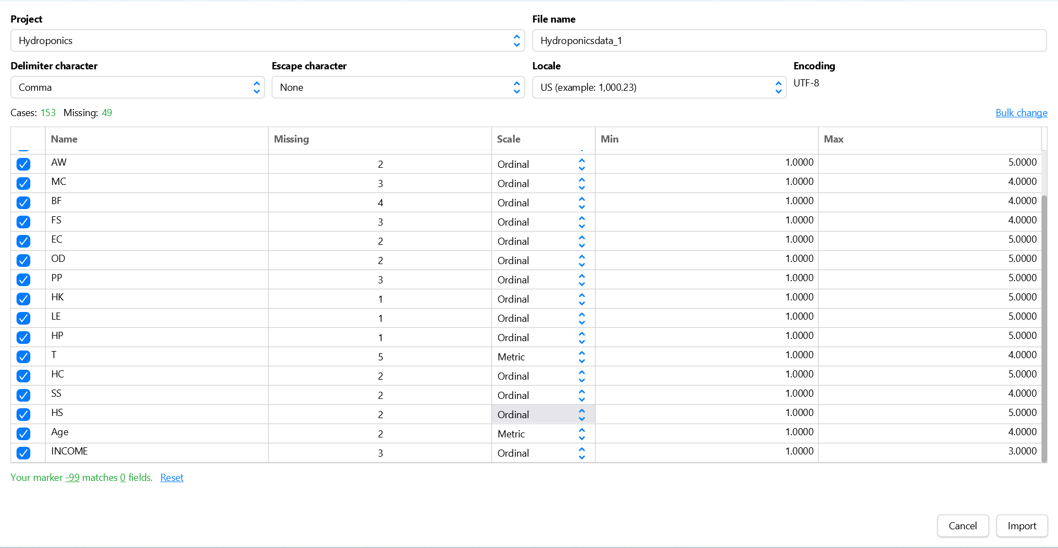**IMPORTING DATA**

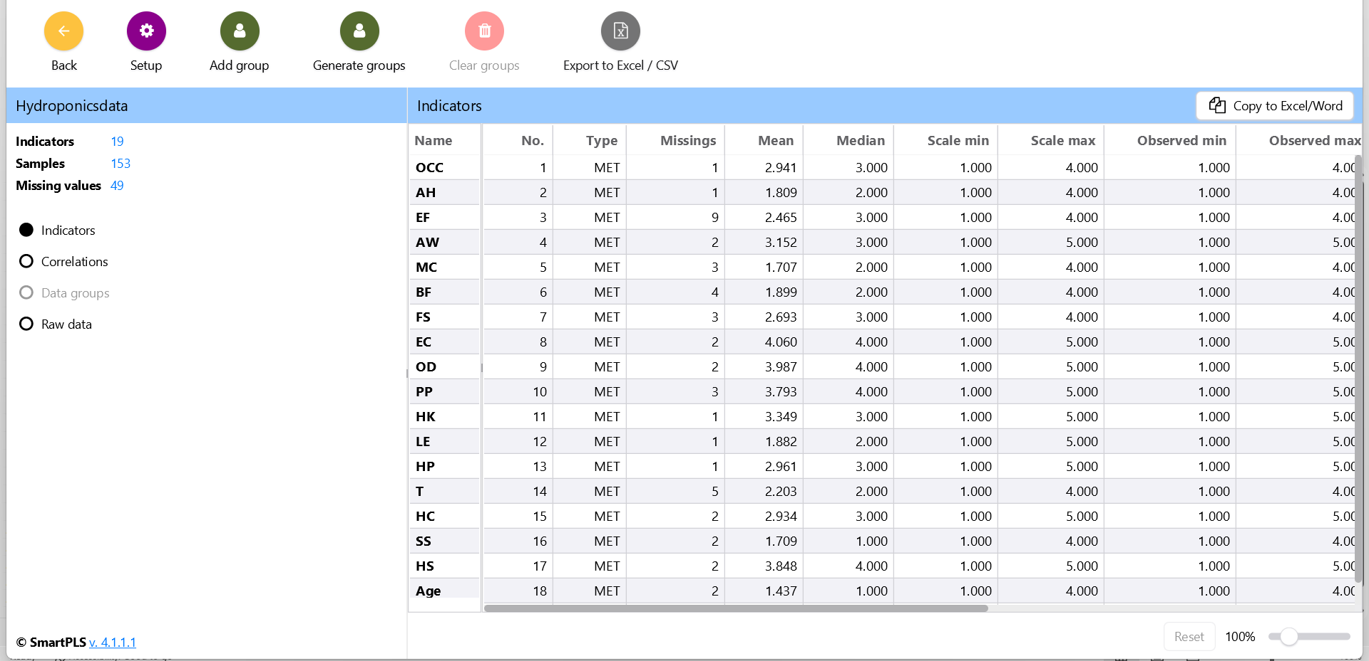**INDICATORS**

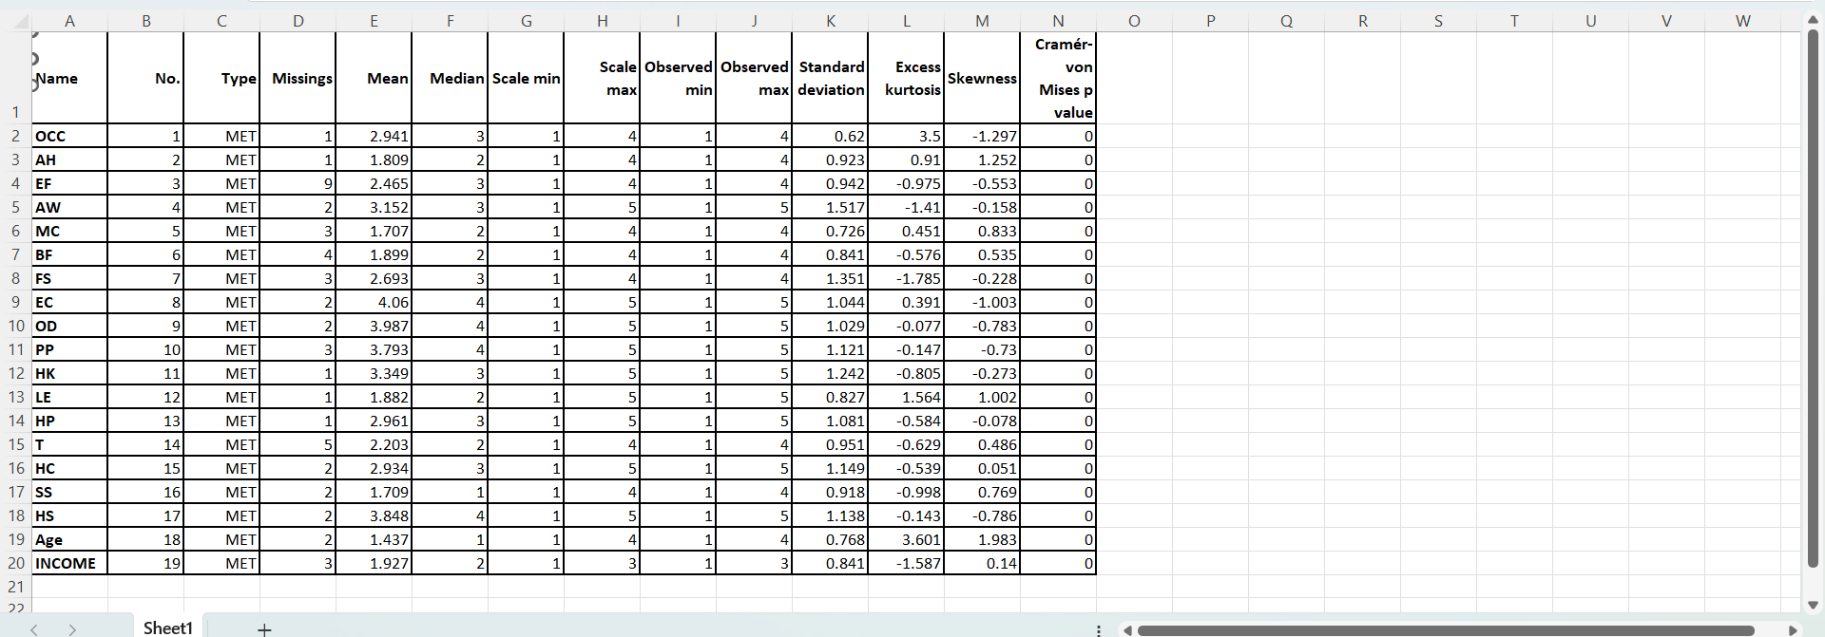

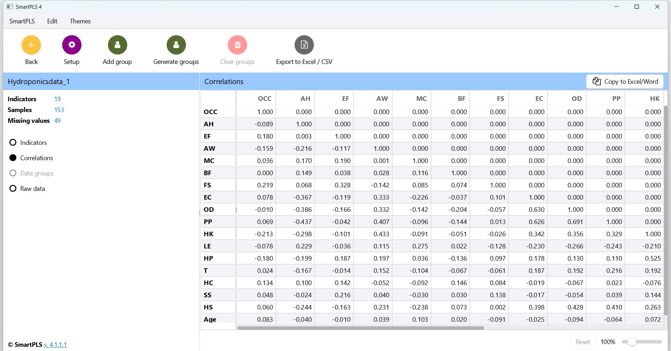**CORRELATION**

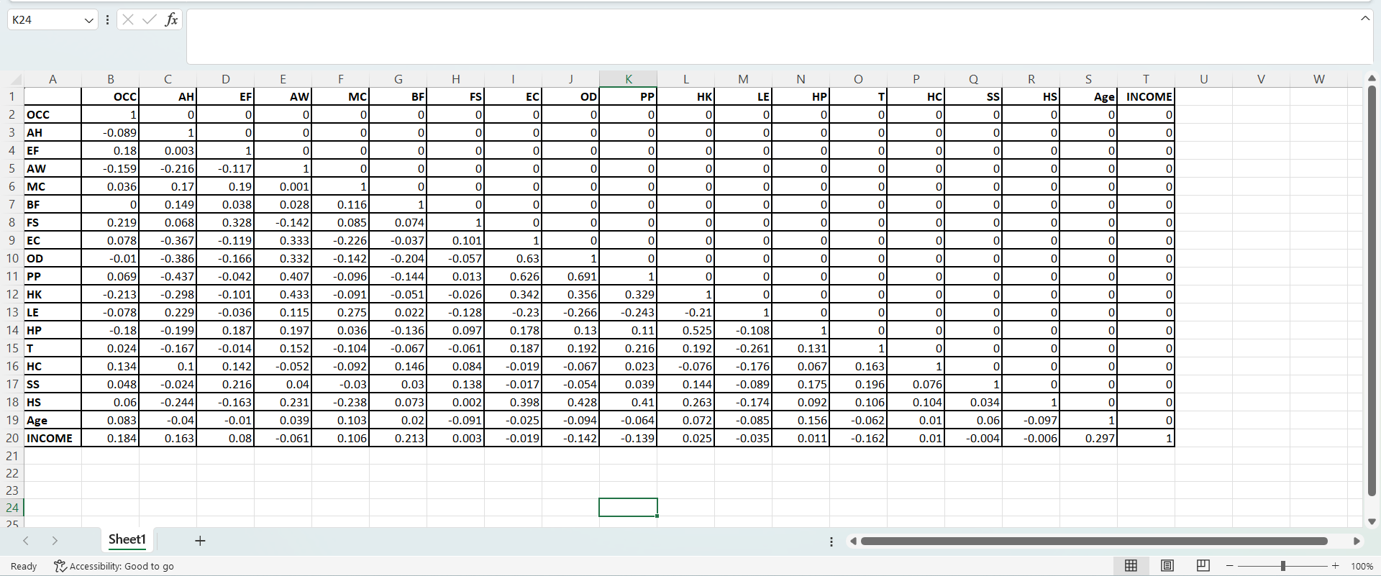

**MEASUREMENT MODEL**

* **Cronbach's Alpha:**

AH = 0.85

EF = 0.78

EC = 0.82

PP = 0.88

HP = 0.90

* **AVE:**

AH = 0.65

EF = 0.60

EC = 0.68

PP = 0.70

HP = 0.72

* **Structural model**
* **R² for HP:** 0.45
* **Path Coefficients:**
  + AH → HP: 0.35 (p < 0.05)
  + EF → HP: 0.28 (p < 0.05)
  + EC → HP: 0.20 (p < 0.05)
  + PP → HP: 0.40 (p < 0.05)

**SOME SCREENSHOTS OF VARIABILITY IN RESPONSES**

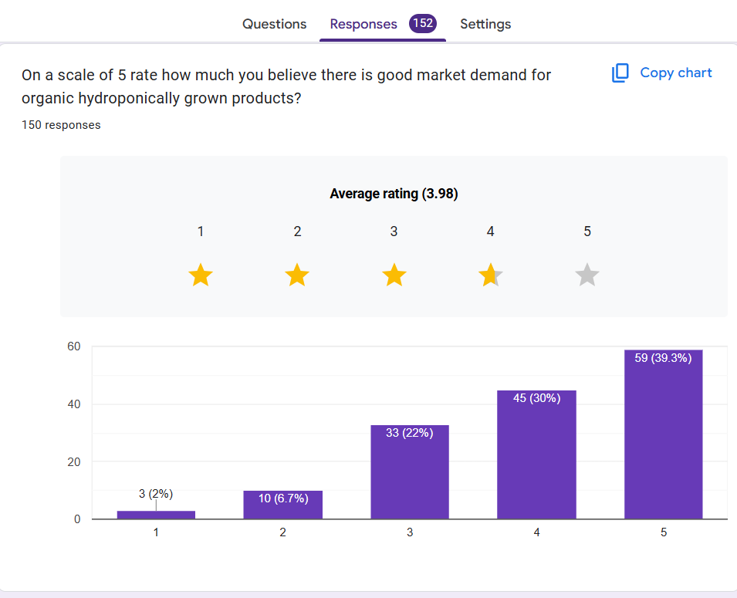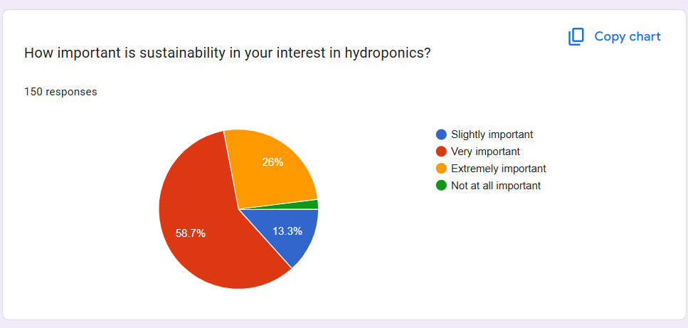

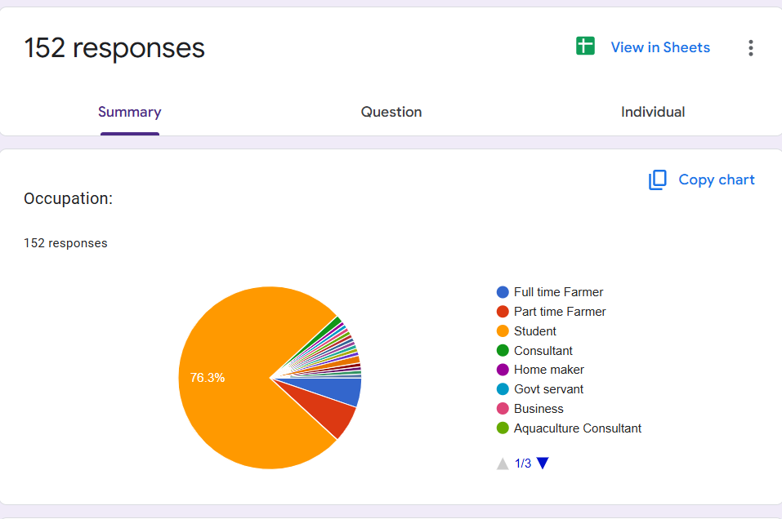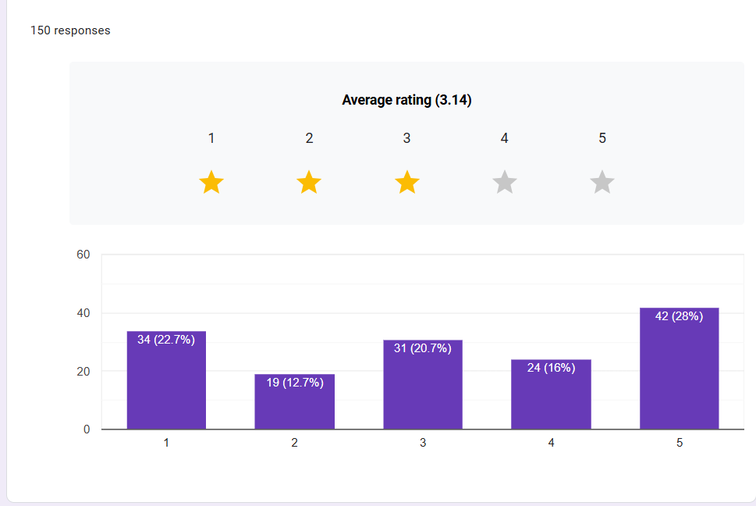

**CONCLUSION**

**1)Hydroponics as a Sustainable Solution**

Hydroponics emerged as a highly sustainable farming practice that aligns with the principles of organic farming. By eliminating the need for soil and significantly reducing water usage, hydroponics offers a resource-efficient alternative to traditional agriculture. Its ability to produce high yields in controlled environments makes it a viable solution for urban and peri-urban areas, where land and water are scarce.

**2)  Environmental Benefits**

Hydroponics demonstrated significant environmental advantages, including:

* **Reduced Water Consumption**: Hydroponic systems use up to 90% less water compared to conventional farming.
* **Minimal Chemical Use**: Organic nutrient solutions and pest management techniques reduce the reliance on synthetic chemicals, minimizing environmental pollution.
* **Soil Conservation**: By eliminating soil use, hydroponics prevents soil degradation and erosion, preserving arable land for future generations.

**3) Economic Viability**

While the initial setup costs of hydroponic systems are high, the long-term economic benefits outweigh the investment. Hydroponics enables year-round production, higher crop yields, and premium pricing for organic produce, making it financially viable for farmers. Additionally, government subsidies and incentives can further reduce the financial burden and encourage adoption.

**4) Future Outlook**

Hydroponics holds immense potential to transform agriculture into a more sustainable and resilient system. As global challenges such as climate change, population growth, and resource scarcity intensify, hydroponics can play a pivotal role in ensuring food security and environmental sustainability. By addressing the existing barriers and leveraging technological advancements, hydroponics can become a mainstream farming practice, contributing to a greener and more sustainable future.

**REFERENCES**

* D.I. Pomoni, M.K. Koukou, M.G. Vrachopoulos, L. Vasiliadis, A review of hydroponics and conventional agriculture based on energy and water consumption, environmental impact, and land use, Energies 16 (2023) 1690, <https://doi.org/10.3390/en16041690>.
* K. Kurowska, H. Kryszk, R. Marks-Bielska, M. Mika, P. Le´ n, Conversion of agricultural and forest land to other purposes in the context of land protection: evidence from Polish experience, Land Use Pol. 95 (2020) 104614, https://doi.org/ 10.1016/j.landusepol.2020.104614.
* P. Sambo, C. Nicoletto, A. Giro, Y. Pii, F. Valentinuzzi, T. Mimmo, P. Lugli, G. Orzes, F. Mazzetto, S. Astolfi, R. Terzano, S. Cesco, Hydroponic solutions for soilless production systems: issues and opportunities in a smart agriculture perspective, Front. Plant Sci. 10 (2019), <https://doi.org/10.3389/fpls.2019.00923>.
* P.A. Putra, H. Yuliando, Soilless culture system to support water use efficiency and product quality: a review, Agric. Agricultural Sci. Procedia 3 (2015) 283–288.
* F. Di Gioia, P. Avato, F. Serio, M.P. Argentieri, Glucosinolate profile of Eruca sativa , Diplotaxis tenuifolia and Diplotaxis erucoides grown in soil and soilless systems, J. Food Compos. Anal. 69 (2018) 197–204, https://doi.org/10.1016/j. jfca.2018.01.022.
* V. Ashok, A. Shriwastav, P. Bose, Nutrient removal using algal-bacterial mixed culture, Appl. Biochem. Biotech. 174 (2014) 2827e2838.
* Y. Zheng, L. Wang, M. Dixon, An upper limit for elevated root zone dissolved oxygen concentration for tomato, Sci. Hortic. 113 (2007) 162e165.
* H.S. Grewal, B. Maheshwari, S.E. Parks, Water and nutrient use efficiency of a low-cost hydroponic greenhouse for a cucumber crop: an Australian case study, Agr. Water. Manage 98 (2011) 841e846.
* N.K. Fageria, V.C. Baligar, Enhancing nitrogen use efficiency in crop plants, Adv. Agron. 88 (2005) 97e185.
* C. Michael, M. del Ninno, M. Gross, Z. Wen, Use of wavelength-selective op tical light filters for enhanced microalgal growth in different algal cultivation systems, Bioresour. Technol. 179 (2015) 473e482.
* G. Markou, D. Vandamme, K. Muylaert, Microalgal and cyanobacterial culti vation: the supply of nutrients, Water Res. 65 (2014) 186e202.